**Lab 4 – Guestbook in PHP**

Create the following Guestbook in PHP  
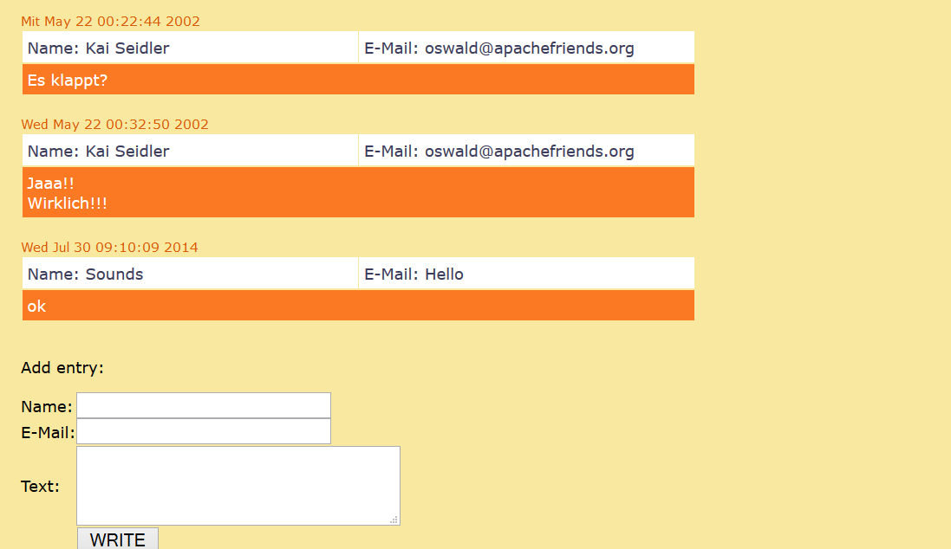

Note: Save the entries in MYSQL and load the entries from it when user opens the guestbook!

**If there are no entries then display**

“No Entries Yet! Be the first one to add a entry ☺ ”